**Java Programming: Practical 1**

A Letter to Yourself

1. Write a program that displays your name and address on the screen as if it were a letter. Your output should look something like that below.

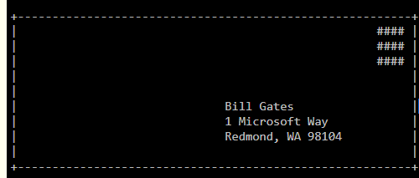

1. Write a Java program to print a face.

+"""""+

[| o o |]

| ^ |

| '-' |

+-----+

1. Write a program that displays your initial as shown below

A screenshot of text

Description generated with very high confidence